The purpose of the imageJ macro:

Generate mask for STOMP in imageJ/Fiji

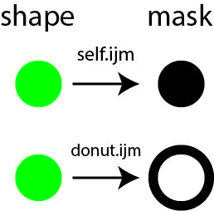

The macros are generated in Fiji version 1.52o.